**UG Semester 3**

**09/11/2021**

**Graph Theory**



Graph is an entity which consists of a tuple G(V,E) where V is called non empty set of vertices and E is set of edges.

Edge: An edge is a line joining two vertices.

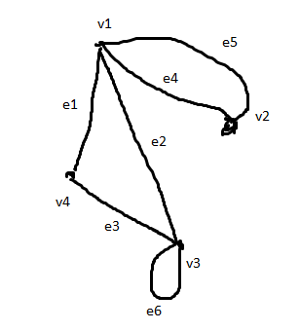

V={v1,v2,v3,v4}

E={e1,e2,e3,e4,e5,e6}

e1: (v1,v4) unordered pair of two vertices

e2:(v1,v3)

e3:(v4,v3)

e4:(v1,v2)

e5:(v1,v2)

e6:(v3,v3)

e4,e5: Parallel edge: If the edges have corresponding identical end vertices.

e6: self loop: If the end vertices of an edge is identical.

Simple graph: A graph without parallel edge and self loop is called simple graph.

Multi-graph: A graph which may contain parallel edge and self loop is called multi graph.

Degree of a vertex: The number of edges incident on a vertex.

deg(v1)=4

deg(v2)=2

deg(v3)=4

deg(v4)=2

Total degree of the graph=4+2+4+2=12=2x6=2x|E|

**Proof:** Let us consider a graph G(V,E) has n1 number of even vertices and n2 number of odd vertices.

Total degree of G=Even=2*|E|

Total degree of n1 vertices + Total degree of n2 vertices=Even

or Even + Total degree of n2 verices=Even

or Total degree of n2 verties=Even

Hence n2 must be even. (proved)

**How to test whether a vector is graphical or not?**

Hakimi-Havel Theorem( Balakrishnan)

V={3,2,3,2} sort in descending order

V={3,3,2,2} Delete first vertex

={0,2,1,1} sort in descending order

={2,1,1,0} delete first vertex

={0,0,0,0} Null vector

So the vector is graphical.

V={3,2,2,1} delete first vertex

={0,1,1,0}

={1,1,0,0} delete first vertex

={0,0,0,0} Null vector

V={3,3,3,2,2} delete first vertex

={0,2,2,1,2} arrange

={2,2,2,1,0} delete first vertex

={0,1,1,1,0} arrange

={1,1,1,0,0} delete first vertex

={0,0,1,0,0} arrange

={1,0,0,0,0} delete first vertex

={0,-1,0,0,0} not a null vector

* Implement Hakimi Havel theorem.

**Complete Graph (Kn):** A graph G(V,E) is complete if each vertex is adjacent to every other vertices.

Adjacent: Has edge

n represents number of vertices.

In a complete graph with n vertices each vertex has degree (n-1).

Total degree of the graph=n*(n-1)=2*|E|

Total number of edges is complete graph with n vertices is :

$$|E|=\frac{n*(n-1)}{2}$$

**Regular graph:** A graph in which all vertices has identical degrees.

Is complete graph regular? Yes.

But the converse is not true.

**Cubic graph**: If all vertices of a graph is 3.

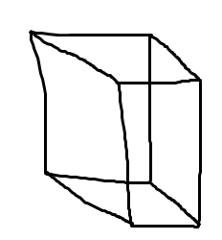

**Cyclic graph**: If all vertices has degree 2.

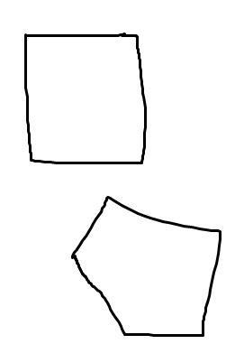

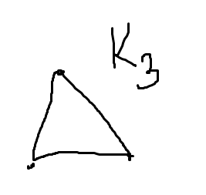

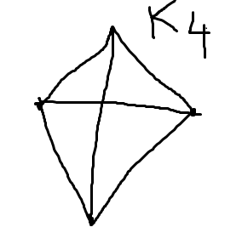

**Complement of a graph:** A graph G’(V,E’) is a complemt of a graph G(V,E) if any edge e whose end vertex is (u,v) belongs to E than it does not belong to E’ and vice versa.

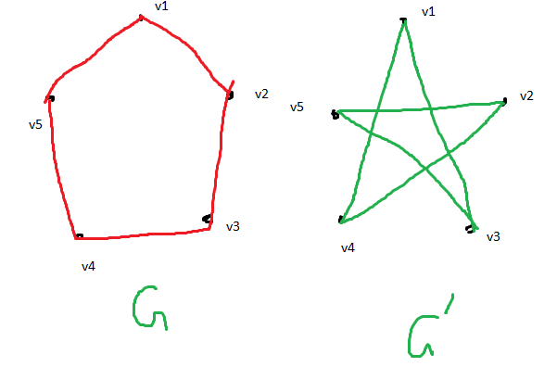

If we combine G and G’ we will get a complete graph.

